1. **Query a list of CITY names from STATION for cities that have an even ID number. Print the results in any order, but exclude duplicates from the answer.**

Ans: Select distinct city from station where id%2=0;

1. Find the difference between the total number of **CITY** entries in the table and the number of distinct **CITY** entries in the table.  
   Select count(city) - count(distinct city)from station;

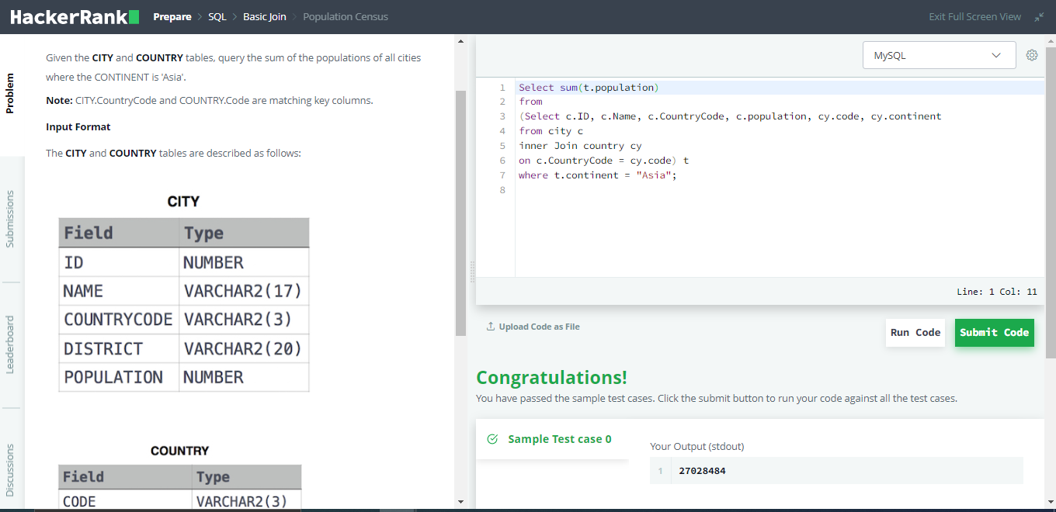  
Select sum(t.population)

from

(Select c.ID, c.Name, c.CountryCode, c.population, cy.code, cy.continent

from city c

inner Join country cy

on c.CountryCode = cy.code) t

where t.continent = "Asia";

1. Query the average population for all cities in **CITY**, rounded down to the nearest integer.  
   Select floor(avg(population)) from city;
2. Query the difference between the maximum and minimum populations in **CITY**.  
   Select max(population) - min(population) from city;
3. 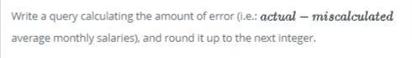

Select Ceil((AVG(Salary)) - AVG(Replace(Salary, '0', ''))) from Employees;